Design document

Muhammad Umar Farooq – 180034882

Aston University

CS2150: Computer Graphics

Contents:

Introduction/Main Idea of the Coursework: 2

Scene Graph: 2

User Interaction/Animations: 2

Custom 3D Object: 3

Farm Pickup Truck: 3

Truck Roof: 3

Truck Hood: 3

Truck Back: 4

Conclusion: 5

Bibliography: 5

Other References: 5

# Introduction/Main Idea of the Coursework:

The main idea of this coursework is to display a show of my understanding of the OpenGL graphics library in Java which was covered within the lab classes. This will be achieved by creating a scene with simple 3D animations as well as at least one advanced animation which is based around the theme of a farm. Moreover, there will be some interactive animations and a custom 3D object within the scene.

# Scene Graph:

* Scene origin

* +-- [T(0,-1,-10) S(25,1,20)] Ground plane

* +-- [T(0,4,-20) Rx(90) S(25,1,10)] Sky plane

* +-- [T(moonX,moonY,-19) S(0.6,0.6,0.6)] Moon

* +-- [T(sunX,sunY,-19) S(0.6,0.6,0.6)] Sun

* +-- [T(-3,0,-10) S(2,2,2) Ry(40)] Barn Base

* +-- [T(0,0.75,0) S(1,0.5,1)] Barn Roof

* +-- [T(-0.5001,-1.5,-0.28) Ry(-90) S(3,2,1.5)] Barn Door

* +-- [T(-3.0,-1.57,-10) S(2,3,2) Ry(10) Rx(18.4)] Windmill Stand

* +-- [T(-2.7,1.45,-9.95) S(1.5,1.5,1.5) Ry(10) Rz(windmillSpin)] Windmill Blades

* +-- [T(moveTruck+1,-0.65,-5) S(1,0.7,1)] Truck Hood

* +-- [T(moveTruck,-0.65,-5) S(1,0.7,1)] Truck Back

* +-- [T(moveTruck+0.7,-0.3,-5) S(0.85,0.7,1)] Truck Top/Roof

* +-- [T(moveTruck+0.7,-0.3,-5) S(0.85,0.7,1)] Truck Windows

* +-- [T(moveTruck+1.05,-0.83,-4.68) Rz(truckWheelSpin) S(0.14,0.14,0.05)] Truck Front Right Wheel

* +-- [T(moveTruck+1.05,-0.83,-5.31) Rz(truckWheelSpin) S(0.14,0.14,0.05)] Truck Front Left Wheel

* +-- [T(moveTruck,-0.83,-4.68) Rz(truckWheelSpin) S(0.14,0.14,0.05)] Truck Back Right Wheel

* +-- [T(0,-0.1,-15) S(25,2,0)] Fence

# User Interaction/Animations:

My animation is set on a farm with a sky and ground plane. There is also a barn and a fence around the farm. There is a windmill which is spinning due to the wind. The more complex animations involve the truck on the farm which the user can interact with by moving it forward and back while the wheels on the truck also spin in accordance with the truck moving forward or back. Another complex animation is the day and night cycle where the moon comes up and the lighting gets darker gradually while also a starry night sky is displayed. Then once the moon goes down, the sunrises and the lighting gets brighter gradually and a cloudy sky is displayed; this repeats for as long as the animation is open.

# Custom 3D Object:

## Farm Pickup Truck:

My custom 3D object is a pickup truck which is made from the three shapes below.

### Truck Roof:

|  |  |  |  |  |  |  |
| --- | --- | --- | --- | --- | --- | --- |
| Coordinates: | | | |  | Faces: | |
| Vertex | x | y | z |  | Face | Vertices |
| v1 | 0.5 | 0.25 | 0.4 |  | Near face | v4, v3, v2, v1 |
| v2 | 0.5 | 0.25 | 0.4 |  | Left face | v2, v6, v5, v1 |
| v3 | 0.2 | 0.25 | 0.4 |  | Right face | v8, v7, v3, v4 |
| v4 | 0.5 | -0.25 | 0.4 |  | Top face | v3, v7, v6, v2 |
| v5 | -0.5 | -0.25 | -0.4 |  | Bottom face | v8, v4, v1, v5 |
| v6 | 0.5 | 0.25 | -0.4 |  | Far face | v5, v6, v7, v8 |
| v7 | 0.2 | 0.25 | -0.4 |  |
| v8 | 0.5 | -0.25 | -0.4 |  |

### Truck Hood:

|  |  |  |  |  |  |  |
| --- | --- | --- | --- | --- | --- | --- |
| Coordinates: | | | |  | Faces: | |
| Vertex | x | y | z |  | Face | Vertices |
| v1 | -0.5 | -0.25 | 0.4 |  | Near left face | v2, v1, v10, v9, v8, v22 |
| v2 | -0.5 | 0.25 | 0.4 |  | Near middle face | v7, v21, v22, v8 |
| v3 | 0.5 | 0.25 | 0.4 |  | Near right face | v4, v3, v21, v7, v6, v5 |
| v4 | 0.5 | -0.25 | 0.4 |  | Left face | v1, v2, v13, v14 |
| v5 | 0.25 | -0.25 | 0.4 |  | Right face | v11, v12, v3, v4 |
| v6 | 0.25 | -0.05 | 0.4 |  | Top face | v3, v12, v13, v2 |
| v7 | 0.225 | 0 | 0.4 |  | Far left face | v12, v11, v20, v19, v18, v23 |
| v8 | -0.125 | 0 | 0.4 |  | far middle face | v17, v24, v23, v18 |
| v9 | -0.15 | -0.05 | 0.4 |  | far right face | v14, v13, v24, v17, v16, v15 |
| v10 | -0.15 | -0.25 | 0.4 |  | bottom left face | v15, v10, v1, v14 |
| v11 | 0.5 | -0.25 | -0.4 |  | wheel space left face | v15, v15, v9, v10 |
| v12 | 0.5 | 0.25 | -0.4 |  | wheel space angle left face | v16, v17, v8, v9 |
| v13 | -0.5 | 0.25 | -0.4 |  | wheel space top face | v17, v18, v7, v8 |
| v14 | -0.5 | -0.25 | -0.4 |  | wheel space angle right face | v6, v7, v18, v19 |
| v15 | -0.15 | -0.25 | -0.4 |  | wheel space right face | v5, v6, v19, v20 |
| v16 | -0.15 | -0.05 | -0.4 |  | bottom right face | v11, v4, v5, v20 |
| v17 | -0.125 | 0 | -0.4 |
| v18 | 0.225 | 0 | -0.4 |
| v19 | 0.25 | -0.05 | -0.4 |
| v20 | 0.25 | -0.25 | -0.4 |
| v21 | 0.225 | 0.25 | -0.4 |
| v22 | -0.125 | 0.25 | -0.4 |
| v23 | 0.225 | 0.25 | -0.4 |
| v24 | -0.125 | 0.25 | -0.4 |  |

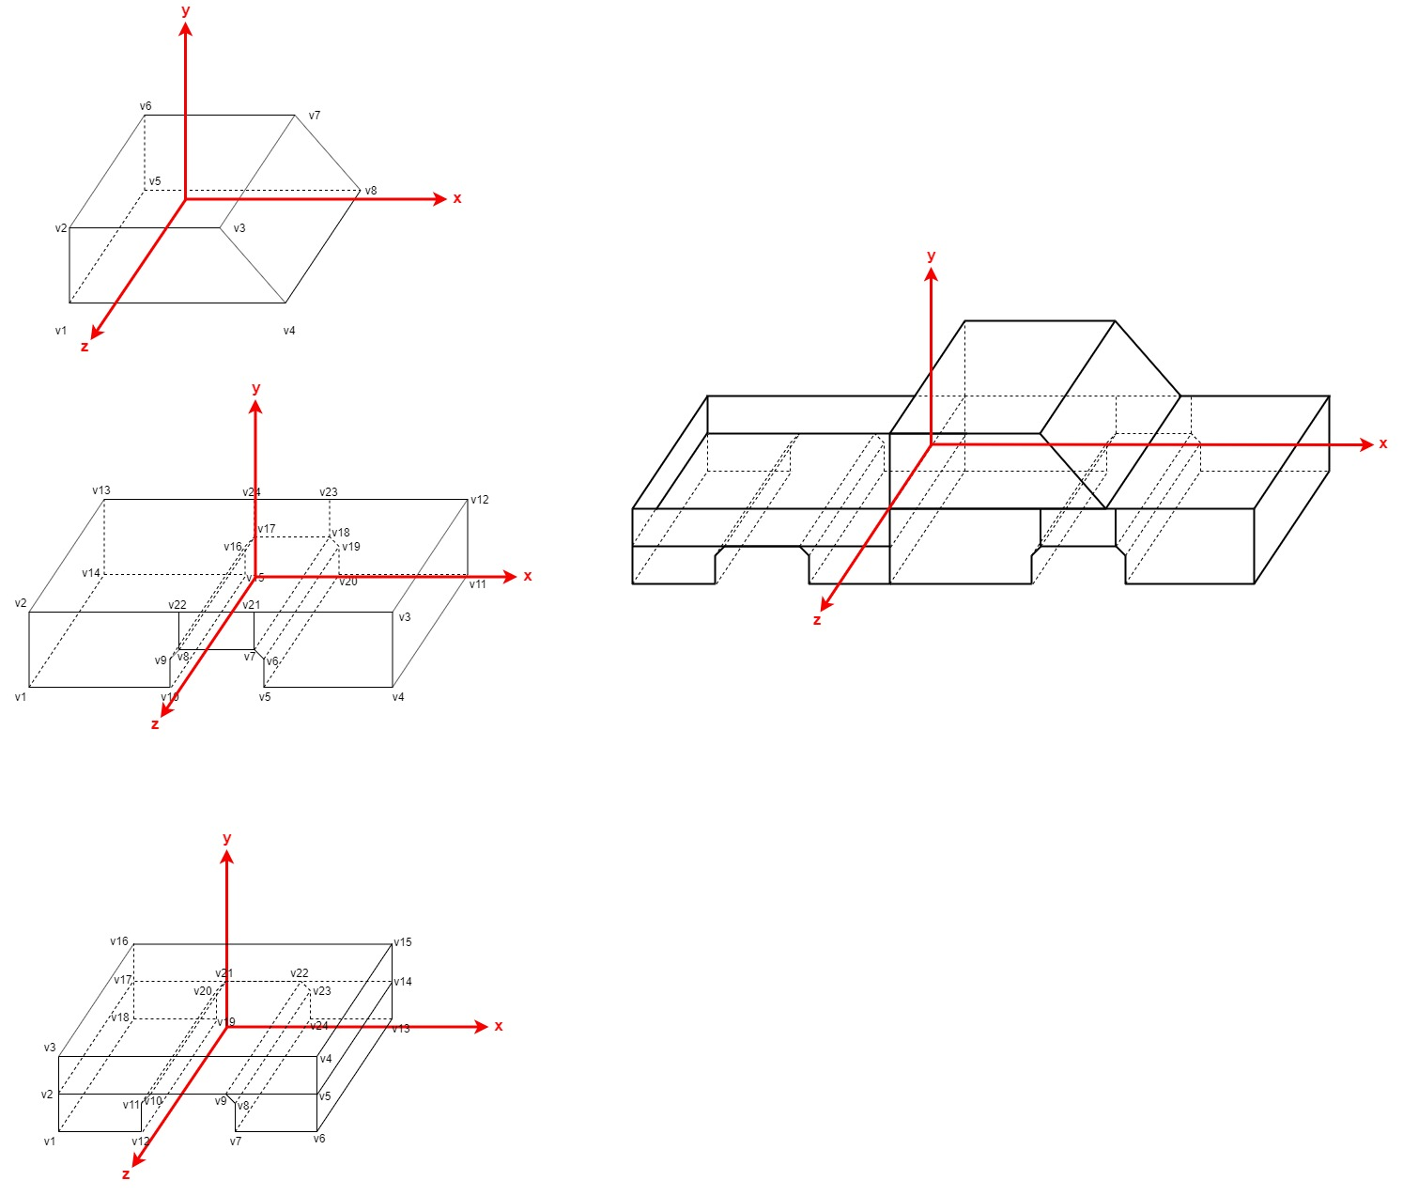

### Truck Back:

|  |  |  |  |  |  |  |
| --- | --- | --- | --- | --- | --- | --- |
| Coordinates: | | | |  |  | |
| Vertex | x | y | z |  |  |  |
| v1 | -0.5 | -0.25 | 0.4 |  |  |  |
| v2 | -0.5 | 0 | 0.4 |  |  |  |
| v3 | -0.5 | 0.25 | 0.4 |  |  |  |
| v4 | 0.5 | 0.25 | 0.4 |  |  |  |
| v5 | 0.5 | 0 | 0.4 |  |  |  |
| v6 | 0.5 | -0.25 | 0.4 |  |  |  |
| v7 | 0.2 | -0.25 | 0.4 |  | Faces: | |
| v8 | 0.2 | -0.05 | 0.4 |  | Face | Vertices |
| v9 | 0.175 | 0 | 0.4 |  | left face | v1, v2, v3, v16, v17, v18 |
| v10 | -0.175 | 0 | 0.4 |  | right face | v13, v14, v15, v4, v5, v6 |
| v11 | -0.2 | -0.05 | 0.4 |  | inner top face | v5, v14, v17, v2 |
| v12 | -0.2 | -0.25 | 0.4 |  | inner near face | v2, v3, v4, v5 |
| v13 | 0.5 | -0.25 | -0.4 |  | inner far face | v14, v15, v16, v17 |
| v14 | 0.5 | 0 | -0.4 |  | inner left face | v17, v16, v3, v2 |
| v15 | 0.5 | 0.25 | -0.4 |  | inner right face | v5, v4, v15, v14 |
| v16 | -0.5 | 0.25 | -0.4 |  | near top face | v5, v4, v3, v2 |
| v17 | -0.5 | 0 | -0.4 |  | near bottom left face | v2, v1, v12, v11, v10 |
| v18 | -0.5 | -0.25 | -0.4 |  | near bottom right face | v6, v5, v9, v8, v7 |
| v19 | -0.2 | -0.25 | -0.4 |  | far top face | v17, v16, v15, v14 |
| v20 | -0.2 | -0.05 | -0.4 |  | far bottom right face | v18, v17, v21, v20, v19 |
| v21 | -0.175 | 0 | -0.4 |  | far bottom left face | v14, v13, v24, v23, v22 |
| v22 | 0.175 | 0 | -0.4 |  | bottom left face | v19, v12, v1, v18 |
| v23 | 0.2 | -0.05 | -0.4 |  | wheel space left face | v19, v20, v11, v12 |
| v24 | 0.2 | -0.25 | -0.4 |  | wheel space angle left face | v20, v21, v10, v11 |
|  |  |  |  |  | wheel space top face | v22, v9, v10, v21 |
|  |  |  |  |  | wheel space angle right face | v8, v9, v22, v23 |
|  |  |  |  |  | wheel space right face | v7, v8, v23, v24 |
|  |  |  |  |  | bottom right face | v13, v6, v7, v24 |

# Conclusion:

Within this coursework I have displayed a show of my understanding of the OpenGL graphics library in Java which was covered within the lab classes. This has been achieved by creating a scene with simple 3D animations as well as at least one advanced animation which is based around the theme of a farm. Moreover, there are some interactive animations and a custom 3D object within the scene.

# Bibliography:

The3rdsequence.com. (2019). Green grass - Download Royalty Free Texture. [online] Available at: https://www.the3rdsequence.com/texturedb/texture/1/green+grass/ [Accessed 16 Dec. 2019].

I-love-png.com. (2019). Fence,Wood,Plank,Home fencing,Grass,Outdoor structure,Plant,Picket fence #4361598 - Free Png Library. [online] Available at: https://i-love-png.com/fence-png-11552940123m7mo7whthv_13358.html [Accessed 18 Dec. 2019].

## Other References:

Other resources that were used within this coursework include the moon as well as the first light from lab 6. Moreover, the ‘drawUnitPlane();’, ‘drawUnitCube();’ and the ‘drawUnitRoof();’ methods were also used from lab 6.